Installation Guide for APK -Android

Sample Screen | Step Description
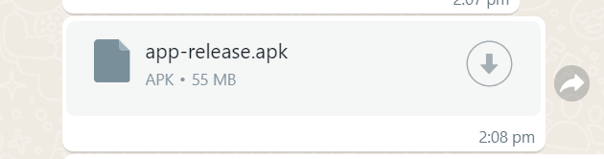 | Click and Download latest Genting Taxi apk file in Whatsapp
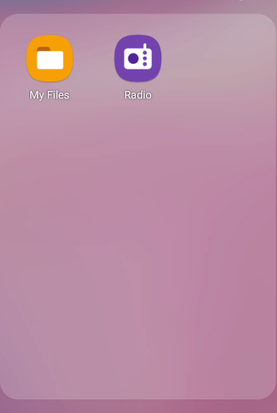 | Go to “My File” in device, check the apk downloaded
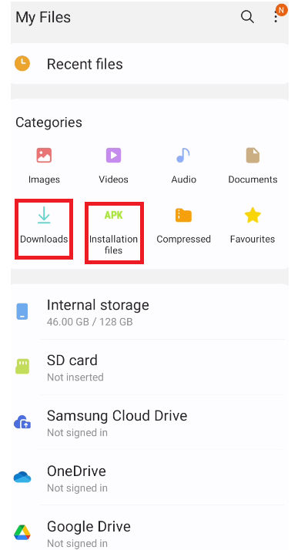 | Select Downloads or APK Installation file in “My File”
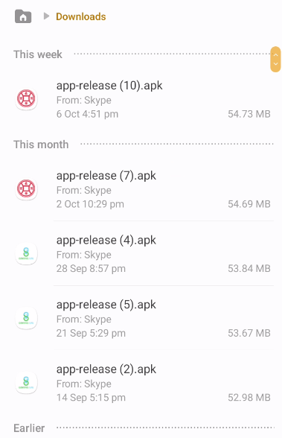  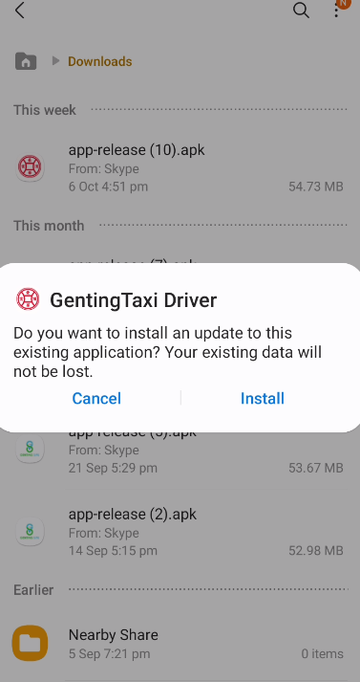 | Select the apk and click Install
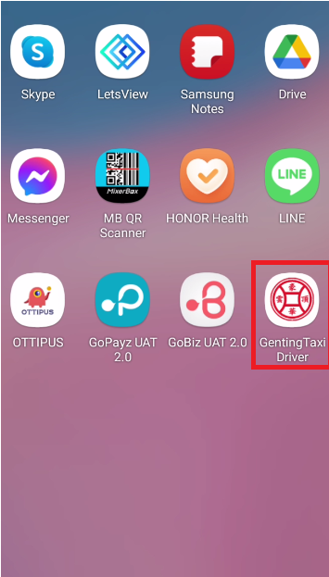 | After installation, you will see the Icon App in device

